**Exercise of Introduction to javaScript**

**1. Prompt for amount, interest rate and no. of years and calculate simple interest.**

Ans : *prompt.html file for this question uploaded in repository*

prompt() used.

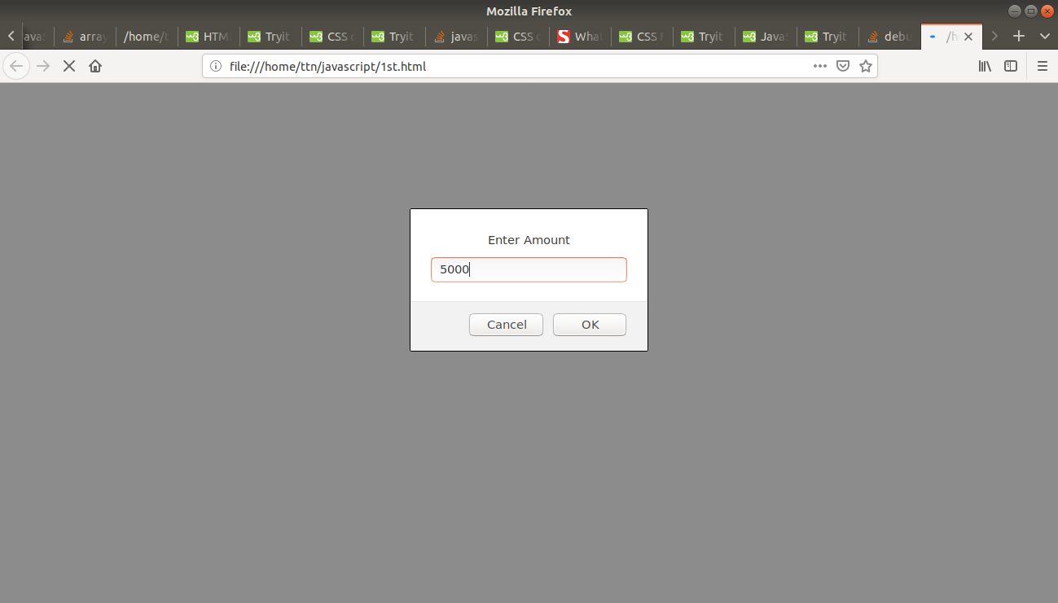

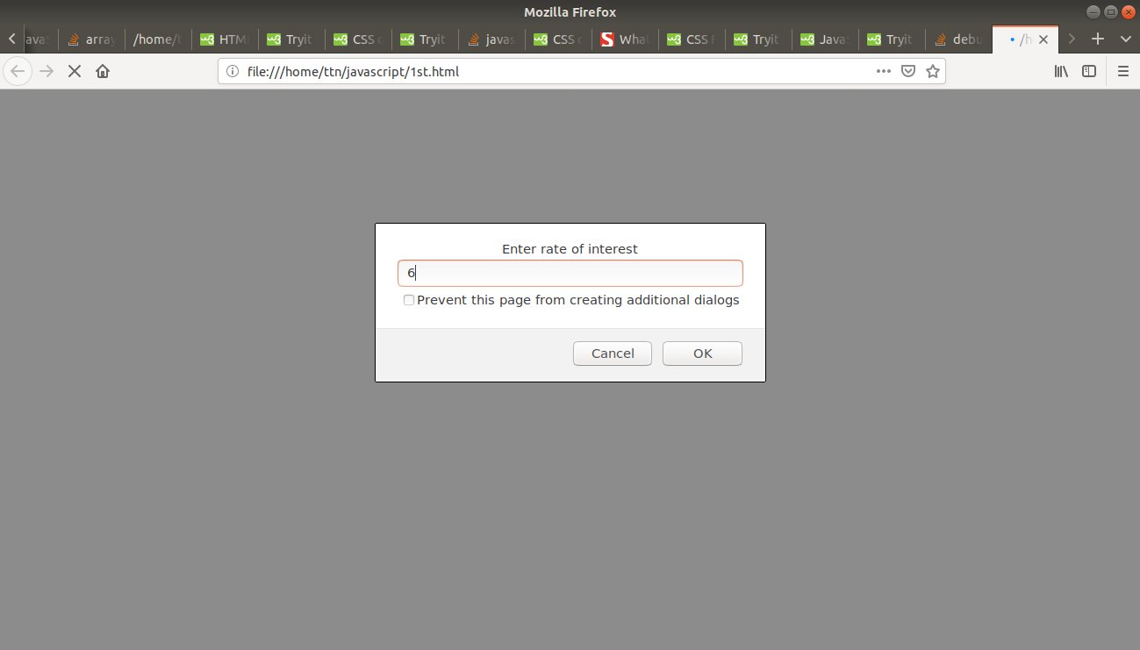

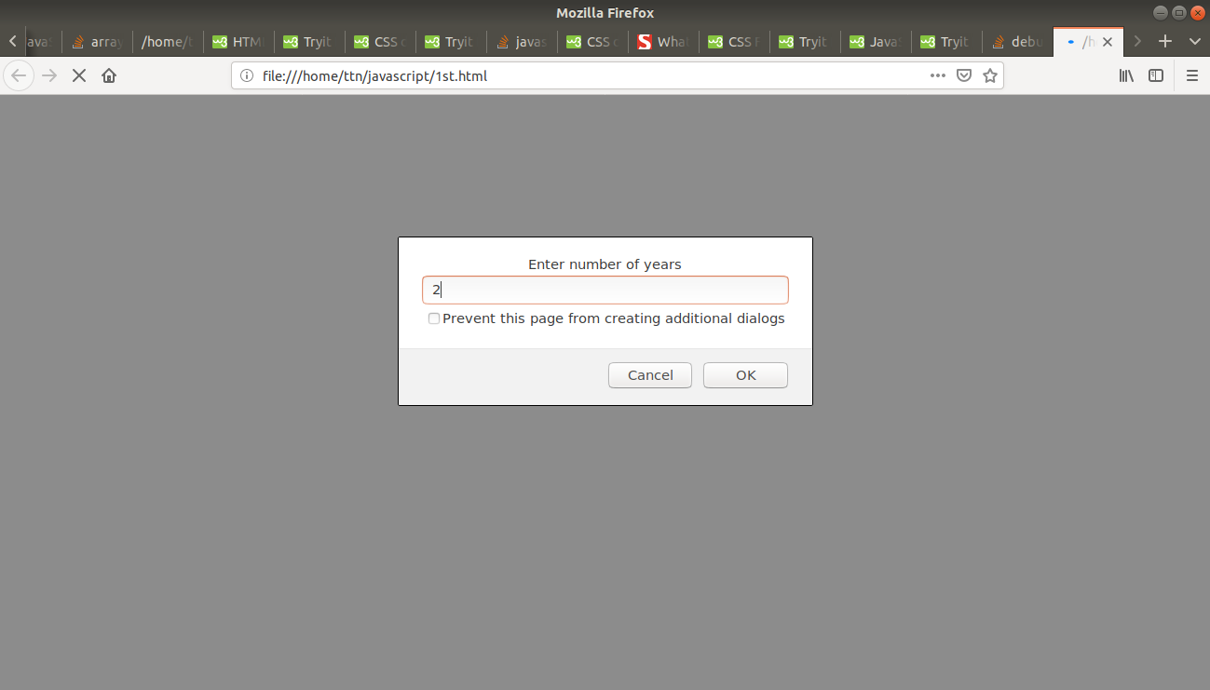

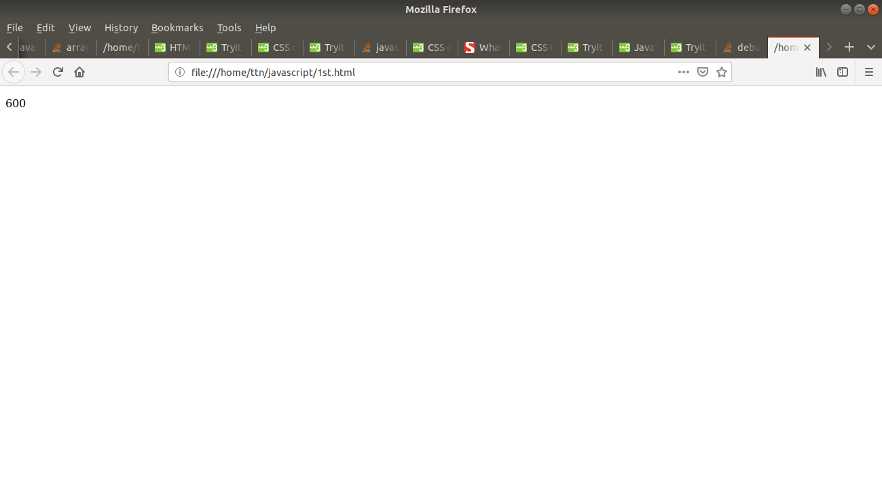

**2. is palindrome string**

Ans:

*Pallindrome.html uploaded for this question.*

User uploads a string in a textbox, and then it is checked and output is shown in lower <div>

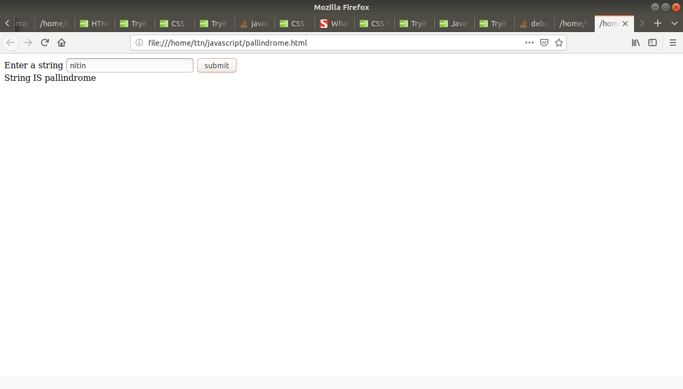

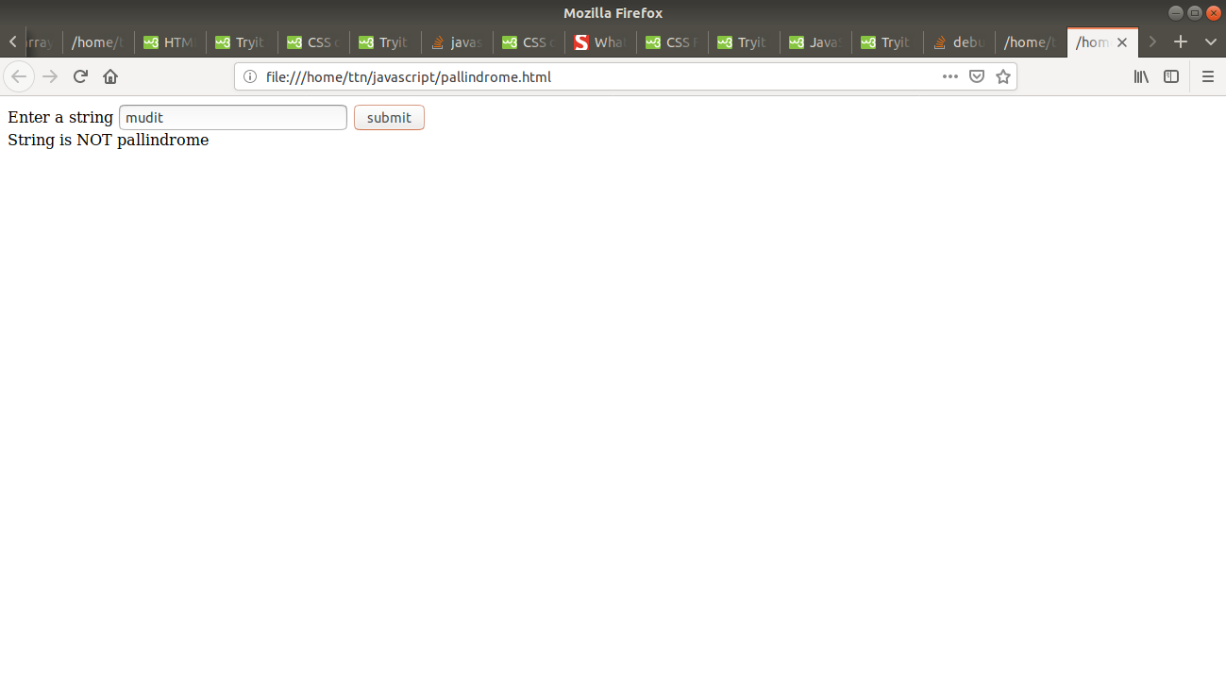

**3. Area of circle**

Ans. *area.html uploaded for this question*

3.14 * radius * radius formula in javaScript

(i forgot to mention units)

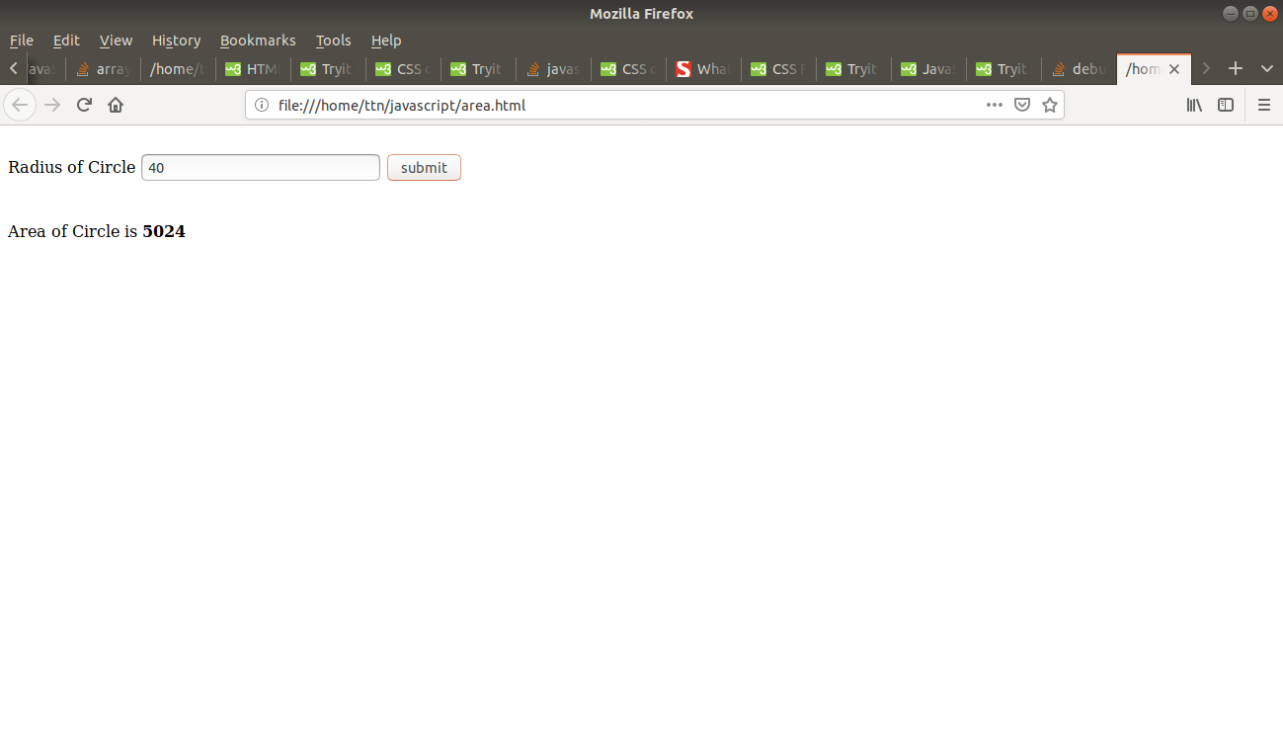

**4. Copy information of one object to another and log it to console.**

Ans : *objcopy.html file uploaded for this question*

Input is going in obj1 object and is being copied to obj2 object using Iterator.

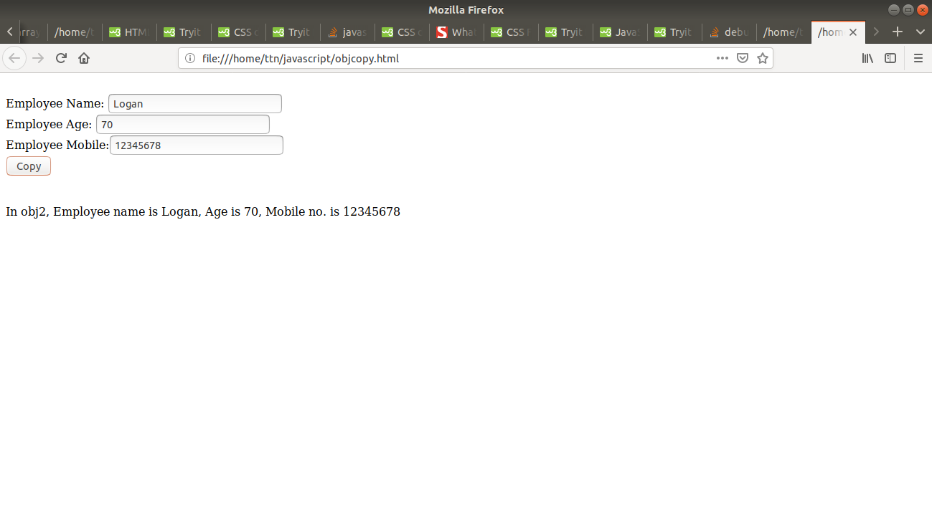

**5. create a list of objects of Employee with info as follow :**

* + **Name, age, salary ,DOB**
  + **filter all employees with salary greater than 5000**
  + **group employee on the basis of their age**
  + **fetch employees with salary less than 1000 and age greater than 20. Then give them an increment 5 times their salary.**

Ans : *last.html uploaded for same*

Concept of array of objects used here. Each textbox is there to collect input for each attribute of object(s) i.e Name, Age, Salary, DOB.

I have made 4 buttons : ADD, FILTER, GROUP, INCREMENT

ADD : When clicked, it will take and store input for nth object of an array. After clicked, all textboxes will be cleared and will be ready to take next input.

FILTER : When clicked, it will show names of all employees whose salary is greater than 5000.

GROUP : When clicked, it will show employees on the basis if their age. I have made 3 groups which represent <=10, >10 and <=20, >20.

INCREMENT : When clicked, it will search for those employees whose salaries are less than 1000 and are over 20 by age. For such employees, their salary is hiked by 5 times their normal salary.

How page looks like :

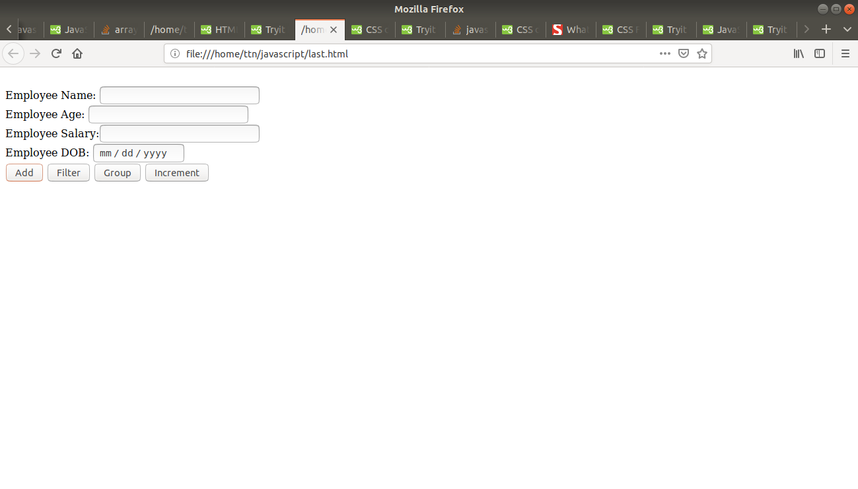

*ADD BUTTON :*

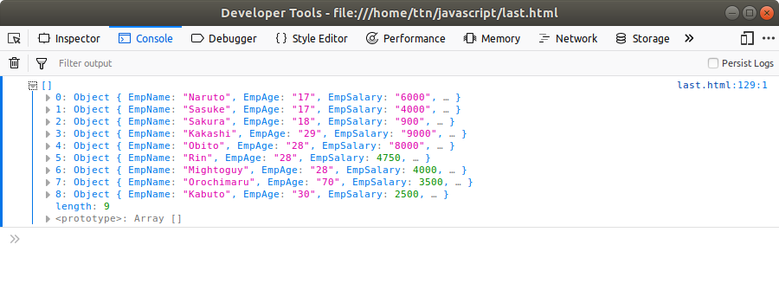

*FILTER BUTTON :*

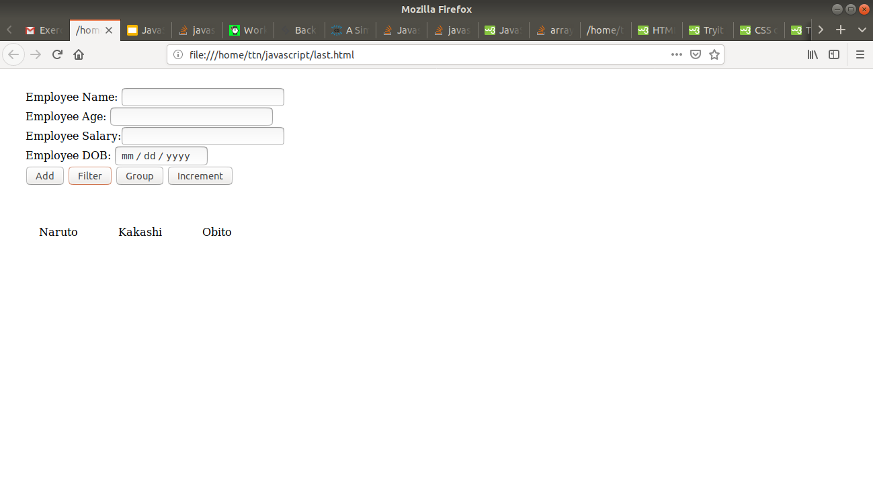

*GROUP BUTTON :*

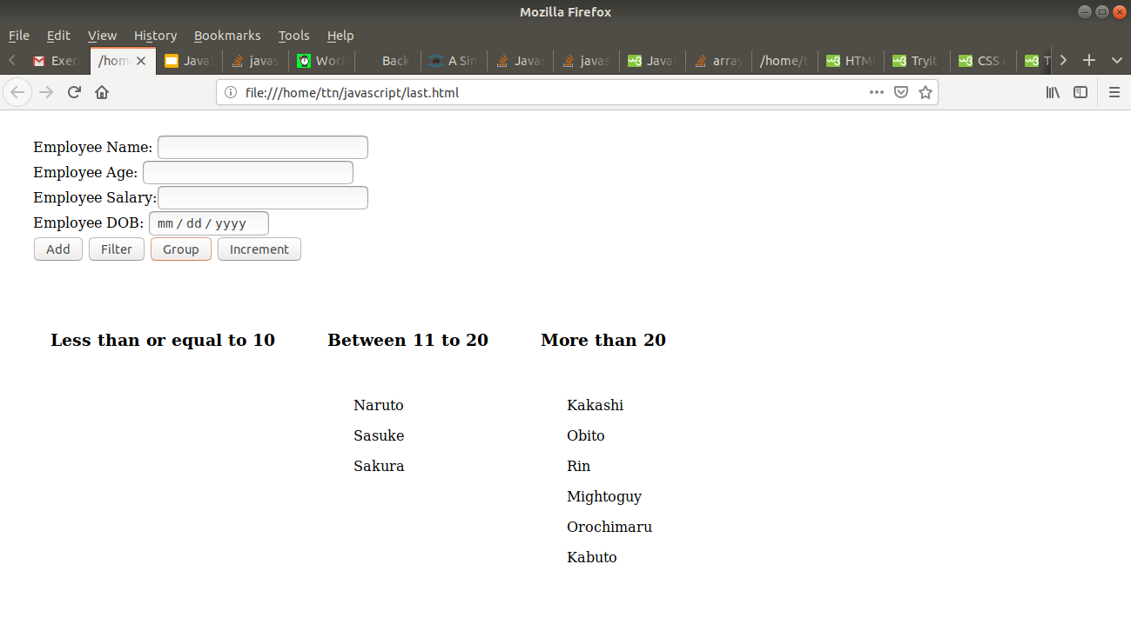

*INCREMENT BUTTON :*

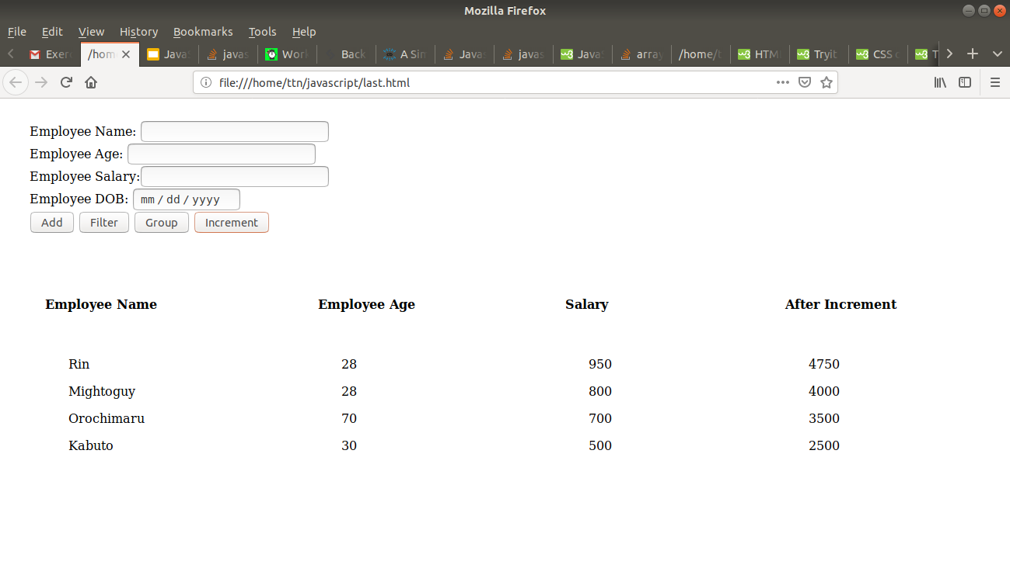

**P.S :** I haven’t copy and pasted all html+js code here because I assumed that it would crowd the document and the formatting would be out of this world which would make it uneasy to read. For this purpose, i have uploaded all those files separately in same repository, all html+css+js combined to avoid confusion in that many number of files.

Edit : I was experimenting was git branches and lost all the html files.